The 7 Layers of the OSI Model

The OSI, or Open System Interconnection, model defines a networking framework for implementing protocols in seven layers. Control is passed from one layer to the next, starting at the application layer in one station, proceeding to the bottom layer, over the channel to the next station and back up the hierarchy.

|  |  |
| --- | --- |
| **Application (Layer 7)** | This layer supports [application](http://www.webopedia.com/quick_ref/application.html) and end-user processes. Communication partners are identified, quality of service is identified, user [authentication](http://www.webopedia.com/quick_ref/authentication.html) and privacy are considered, and any constraints on data [syntax](http://www.webopedia.com/quick_ref/syntax.html) are identified. Everything at this layer is application-specific. This layer provides application services for file transfers, [e-mail](http://www.webopedia.com/quick_ref/e_mail.html), and other [network](http://www.webopedia.com/quick_ref/network.html) [software](http://www.webopedia.com/quick_ref/software.html) services. [Telnet](http://www.webopedia.com/quick_ref/Telnet.html) and [FTP](http://www.webopedia.com/quick_ref/FTP.html) are applications that exist entirely in the application level. [Tiered application architectures](http://www.webopedia.com/quick_ref/app.arch.html) are part of this layer. |
| **Presentation (Layer 6)** | This layer provides independence from differences in data representation (e.g., [encryption](http://www.webopedia.com/quick_ref/encryption.html)) by translating from application to network format, and vice versa. The presentation layer works to transform data into the form that the application layer can accept. This layer formats and encrypts data to be sent across a network, providing freedom from compatibility problems. It is sometimes called the *syntax layer*. |
| **Session (Layer 5)** | This layer establishes, manages and terminates connections between applications. The session layer sets up, coordinates, and terminates conversations, exchanges, and dialogues between the applications at each end. It deals with session and connection coordination. |
| **Transport (Layer 4)** | This layer provides [transparent](http://www.webopedia.com/quick_ref/transparent.html) transfer of data between end systems, or hosts, and is responsible for end-to-end error recovery and [flow control](http://www.webopedia.com/quick_ref/flow_control.html). It ensures complete data transfer. |
| **Network (Layer 3)** | This layer provides [switching](http://www.webopedia.com/quick_ref/switch.html) and [routing](http://www.webopedia.com/quick_ref/routing.html) technologies, creating logical paths, known as [virtual circuits](http://www.webopedia.com/quick_ref/virtual_circuit.html), for transmitting data from [node](http://www.webopedia.com/quick_ref/node.html) to node. Routing and forwarding are functions of this layer, as well as addressing, [internetworking](http://www.webopedia.com/quick_ref/internetworking.html), error handling, congestion control and [packet](http://www.webopedia.com/quick_ref/packet.html) sequencing. |
| **Data Link (Layer 2)** | At this layer, data packets are encoded and decoded into [bits](http://www.webopedia.com/quick_ref/bit.html). It furnishes transmission protocol knowledge and management and handles errors in the physical layer, flow control and frame synchronization. The data link layer is divided into two sub-layers: The [Media Access Control](http://www.webopedia.com/quick_ref/MAC_layer.html) (MAC) layer and the Logical Link Control (LLC) layer. The MAC sub-layer controls how a computer on the network gains access to the data and permission to transmit it. The LLC layer controls frame synchronization, flow control and error checking. |
| **Physical (Layer 1)** | This layer conveys the [bit](http://www.webopedia.com/quick_ref/bit.html) stream - electrical impulse, light or radio signal -- through the network at the electrical and mechanical level. It provides the [hardware](http://www.webopedia.com/quick_ref/hardware.html) means of sending and receiving data on a carrier, including defining cables, [cards](http://www.webopedia.com/quick_ref/card.html) and physical aspects. [Fast Ethernet](http://www.webopedia.com/quick_ref/Fast_Ethernet.html), [RS232](http://www.webopedia.com/quick_ref/RS_232C.html), and [ATM](http://www.webopedia.com/quick_ref/ATM.html) are protocols with physical layer components. |

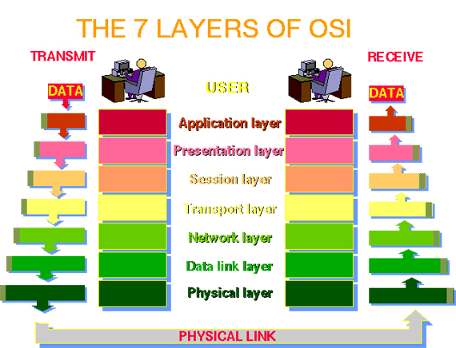

This graphic is taken from [The Abdus Salam International Centre for Theoretical Physics](http://www.ictp.trieste.it/~radionet/1998_school/networking_presentation/index.html).